User Manual for Outlier Detection in Event Logs of Material Handling System

Ozge Koroglu

August 2019

# Application Architecture

The application follows the atchitecture that is presented in Figure Architecture. First we obtain the event log and segments from BPI reports with the help of the Performance Spectrum Miner (PSM) tool. Then we execute the clustering.py if we want to update the clusters for the new interval of date. To get the outliers and outlier patterns for each segment for the given day, we execute the Outlier_Detection_in_BHS.py pipeline. Then the results that were obtained from the Outlier_Detection_in_BHS.py pipeline is visualized in the performance spectrum miner.

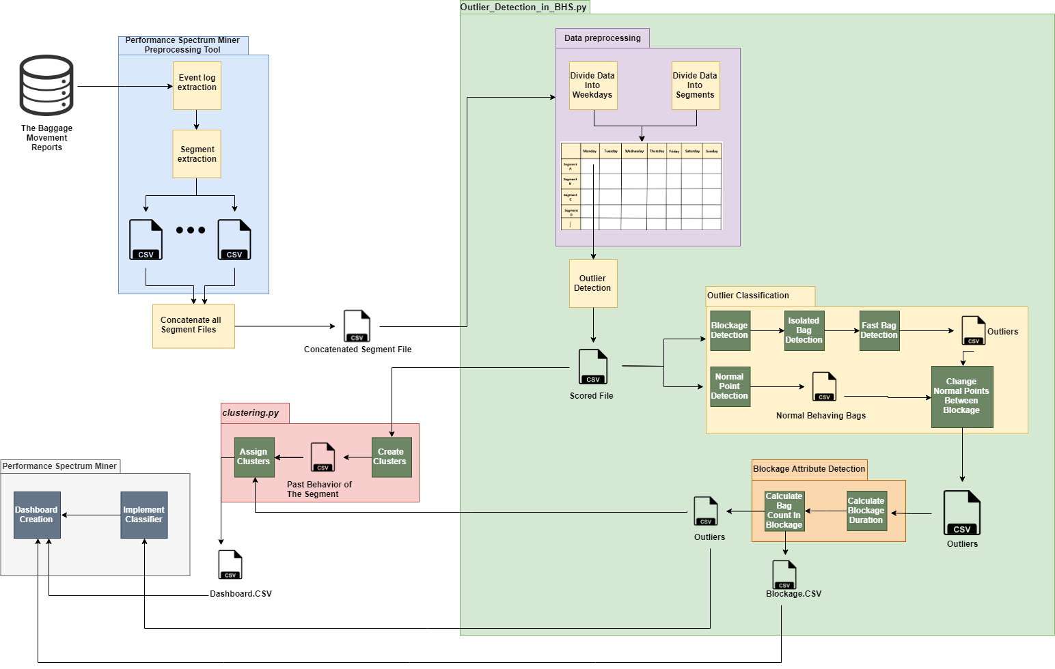

Figure : Architecture

# Environment Setup

## Install Anaconda

Start by accessing the [Jupyter Project website](https://jupyter.org/). In the [install tab](https://jupyter.org/install), the most recommendable installation is described step by step.

We're using the latest version of Python 3 through the [Anaconda distribution](https://www.anaconda.com/download/), so the first step is to download [Anaconda](https://www.anaconda.com/download/) and follow the step by step installation.

## Managing Environments

After Anaconda is installed, we can open the terminal **Anaconda Prompt**. If you'd like to use the graphical user interface, execute anaconda-navigator. Using the terminal Anaconda Prompt is quite straightforward. We can create virtual environments and install packages on them. It is convenient to create a specific virtual environment for a concrete project, to isolate the project and avoid affecting other programs with your modifications in the environment.

### **Create a new environment**

We start by creating a new environment. The command is conda create -n env_name

Also, to specify which version of Python to install in the environment, the command is conda create -n outlier_detection python=3 This command will install the most recent version of Python 3.

### **Activate the new environment**

The new environment has been created in the directory we were located. To activate the new environment, type activate outlier_detection**.**

If you wish to delete an environment, conda env remove -n outlier_detection.

### **Install packages**

Once we have created an environment and it is active, we can install all the packages needed for our software to run.

To install all the required packages at once, since it can take some time, we provide the file **requirements.txt** with the list of packages. Then executing the following command will install all the packages one after the other:

* For Windows:

FOR /F "delims=~" %f in (requirements.txt) DO conda install --yes "%f" || pip install "%f"

Hint: this command must be run from the folder where the **requirements.txt** file is located. Move to the given directory first (e.g. cd Desktop) or just add the path in the command, e.g. FOR /F "delims=~" %f in (Desktop/requirements.txt) DO conda install --yes "%f" || pip install "%f".

## *Necessary instalments*

It is required to have installed:

- Java SDK > 1.8 64-bit 🡪 <https://www.oracle.com/technetwork/java/javase/downloads/index.html>

- Spark > version 2.4.3 🡪 <https://spark.apache.org/downloads.html>

Set HADOOP_HOME environment variable to the path of this folder

You might have to restart your machine for this to take effect

- Scala (sbt) 🡪 <https://www.scala-sbt.org/download.html?_ga=2.123928130.935966207.1567084519-2133533685.1567084519>

- Maven 🡪 <https://maven.apache.org/download.cgi?Preferred=ftp://mirror.reverse.net/pub/apache/>

Check the Maven install

<https://maven.apache.org/install.html>

- Once installed, you will need to add local repositories for 3 pesky dependencies

If you don’t install these dependencies, and you go ahead and try to run the compile command below, you will get the following error:

[warn] ::::::::::::::::::::::::::::::::::::::::::::::

[warn] :: UNRESOLVED DEPENDENCIES ::

[warn] ::::::::::::::::::::::::::::::::::::::::::::::

[warn] :: org.xes-standard#openxes;2.23: not found

[warn] :: org.xes-standard#openxes-xstream;2.23: not found

[warn] :: org.deckfour#Spex;1.0: not found

[warn] ::::::::::::::::::::::::::::::::::::::::::::::

Download the jar files from:

To get:

org.xes-standard#openxes;2.23 and

org.xes-standard#openxes-xstream;2.23

Download from:

<http://www.xes-standard.org/openxes/download>

Make sure you get versions 2.23

You should get a jar file, and downloads folder is fine – but note the path

<http://code.deckfour.org/xes/>

Download the tar.gz file from the big green button, and unzip with your favorite program

In the folder structure, the jar file should be in the lib folder.

An example of the folder structure could be: Spex-1.0tar/Spex-1.0/lib/Spex.jar

Now we are going to install with mavren: <https://maven.apache.org/guides/mini/guide-3rd-party-jars-local.html>

Make sure you fill out the parameter correct, each parameter is described here: <https://stackoverflow.com/questions/4955635/how-to-add-local-jar-files-to-a-maven-project>

# Install The Performance Spectrum Miner

## System Requirements

* Microsoft Windows 7 or higher. The PSM is *not tested* yet on other OS.
* 2 GB RAM minimum, 16 GB RAM recommended
* 2 GB hard disk space for caches recommended
* 1024x768 minimum screen resolution.

## Prequisites

The PSM is implemented and tested with Java 8 and is not compatible with previous Java version (e.g. with Java 7).

1. Install the most recent JRE/JDK 1.8 64bit
2. Make sure that a correct installation of Java is configured: execute java -version in the command line. You should get a response like this:

java version "1.8.0_171"

Java(TM) SE Runtime Environment (build 1.8.0_171-b11)

Java HotSpot(TM) 64-Bit Server VM (build 25.171-b11, mixed mode)

## Installation of PSM

1. Download the project as a ZIP file from <https://github.com/ozgekoroglu/perf_spec>
2. Unzip the folder
3. Open the file location in the command prompt with the following command:

>cd file_path

1. Type the following commands respectively:

>sbt

>compile

>package

>exit



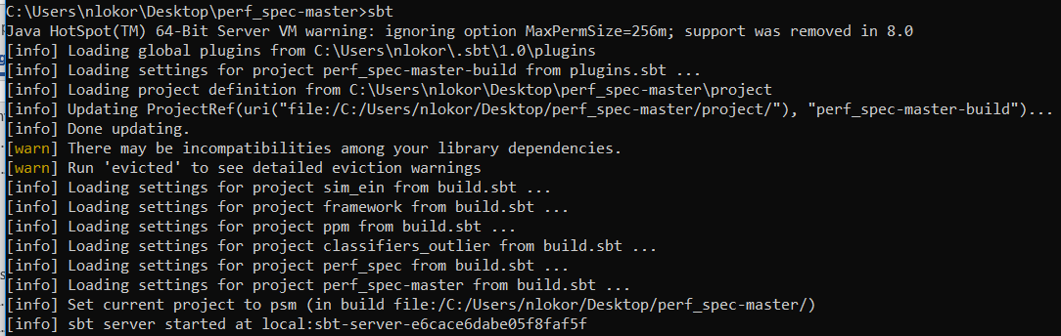

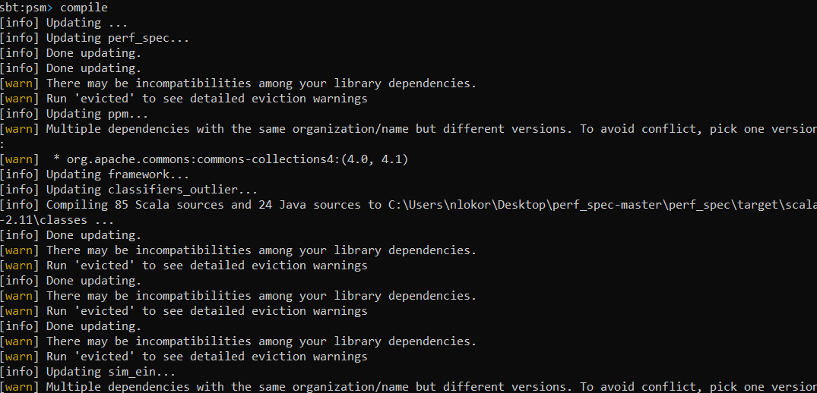

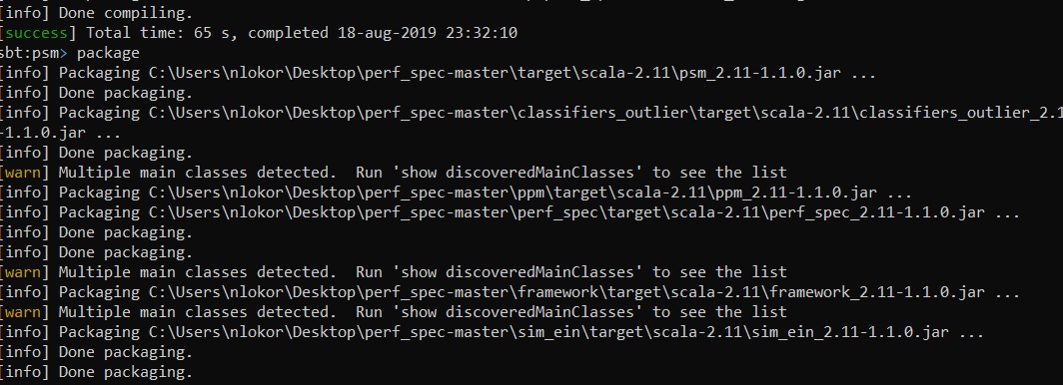



1. Open Intellij. Inside the Intellij, File->Settings-> Build, Execution,Deployment -> Build Tools -> sbt and specify the custom sbt launcher.

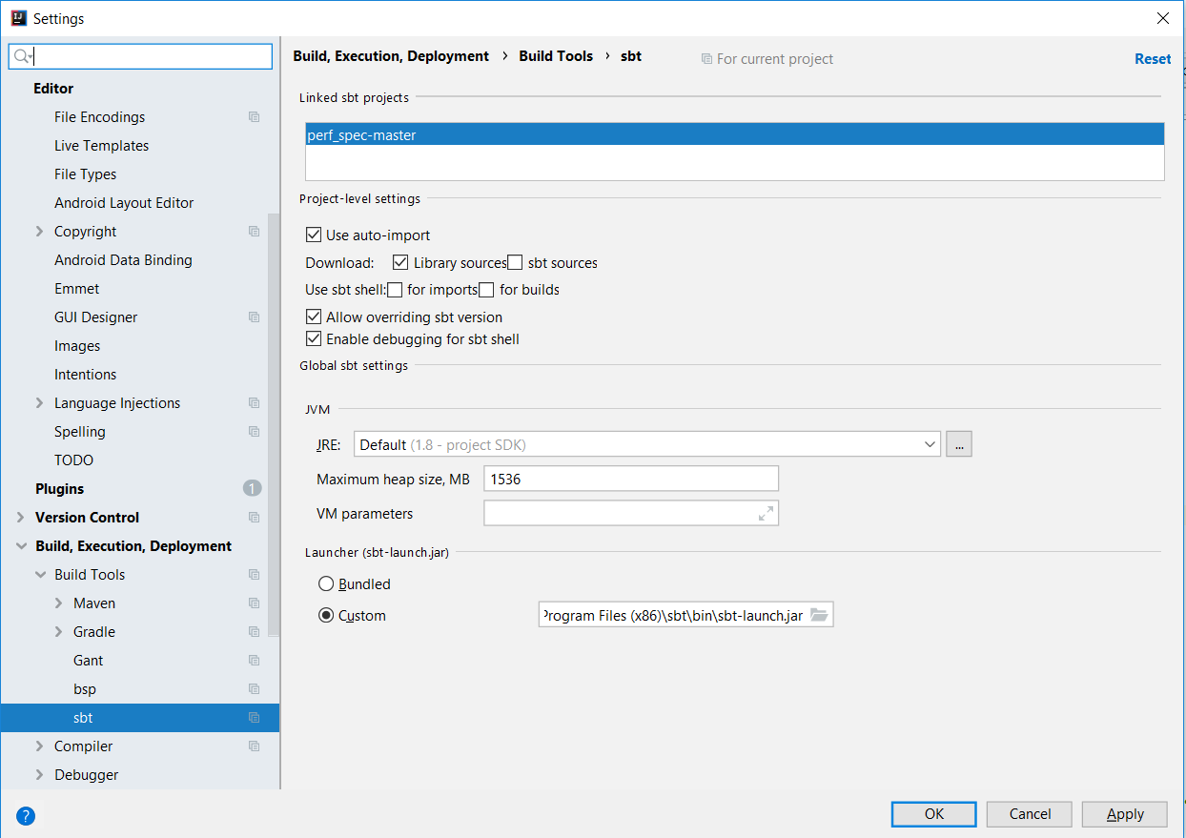

Figure : sbt-launch.jar configuration

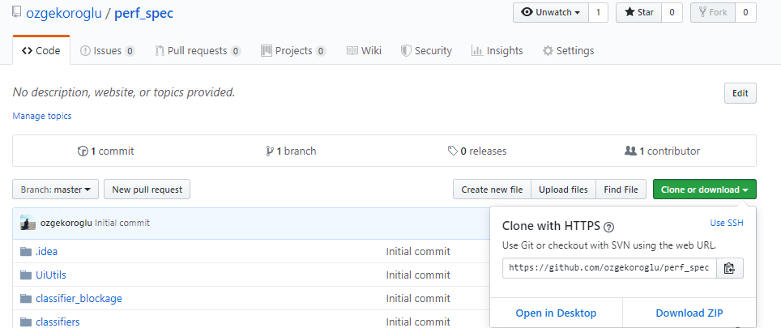

Figure : PSM repository

# Install Intellij

1. From its [website](https://www.jetbrains.com/idea/download/#section=windows), download the community version of Intellij.
2. To create configuration :
3. Open the Run/Debug Configuration dialog:

* Select Run | Edit Configurations from the main menu.
* With the Navigation bar visible (View | Appearance | Navigation Bar), choose Edit Configurations from the run/debug configuration selector.

1. In the Run/Debug Configuration dialog, click + on the toolbar. The list shows the default run/debug configurations. Select the ***Application*** configuration type.
2. For a new run/debug configuration:

* Specify its name in the Name field. This name will be shown in the list of the available run/debug configurations.
* In the Configuration tab, specify the class that contains the main() method, VM options, program arguments, working directory and other configuration-specific settings.

3) Install scala plugin: Open IntelliJ IDEA, go to File Menu --> Plugins --> [ Or directly press Ctrl+Alt+S ] Click on "Browse repositories" button and enter "Scala". Select Scala plugin to install it.

# Execute the Outlier Detection Algorithm

1) Open the downloaded project (perf_spec-master) in Intellij by selecting **File | Open**.

2) Main event log extraction: The initial dataset (BPI reports for Heathrow T3) is used to extract a log that can be used to extract segments (for a Performance Spectrum (PS)). For example, such a log can contain the bag movement (events from sensors and autoscans). In this step, if the log could not fit the memory then it is separated into smaller files (by days or weeks), for the further pre-processing in memory. We execute ***LogSplitter*** method to obtain the event log from the BPI reports. To do that, we create a configuration with the following arguments:

* 1. Location of the BPI reports
  2. Output of the event log

But at the moment they are hard coded at: C:\Users\nljboen\Documents\MasterThesis\perf_spec\sim_ein\src\main\scala\org\processmining\scala\prediction\preprocessing\t3\ms\LogSplitter.scala line 11 and 12. Also modify line 15 and 16 for dates.

The arguments should be given respectively with a space in between. The configuration should be saved by clicking Apply. Then we run the configuration by clicking the run icon in the navigation bar.

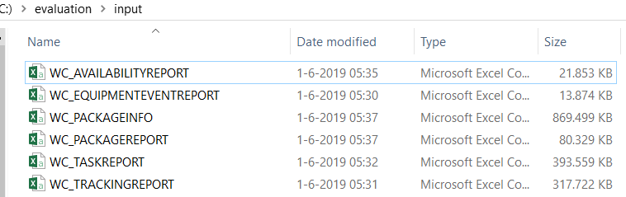

Figure : BPI reports

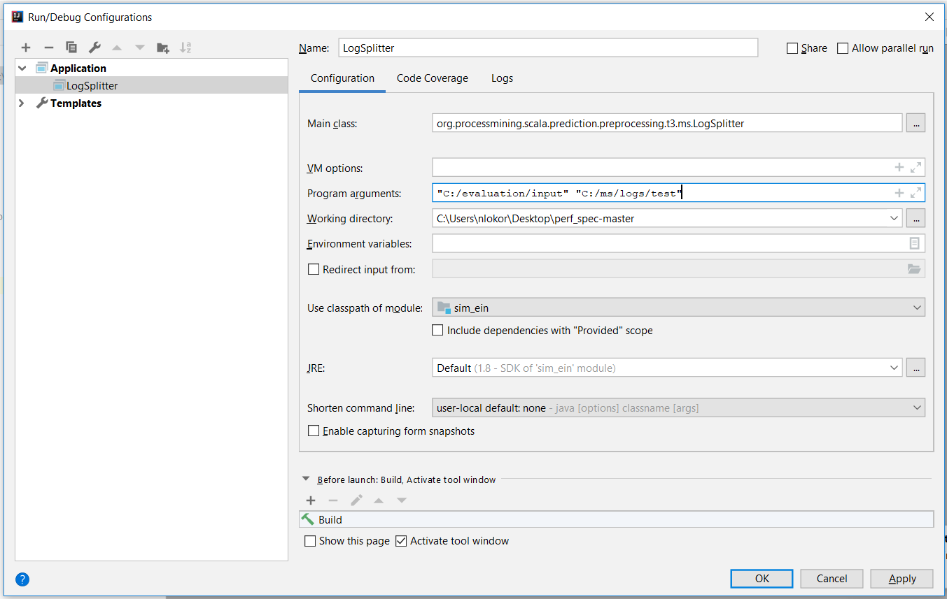

Figure : LogSplitter configuration



Also, any **date-format error** could be because C:\Users\nljboen\Documents\MasterThesis\perf_spec\framework\src\main\scala\org\processmining\scala\applications\mhs\bhs\t3\eventsources\BpiCsvImportHelper.scala line 35 might need to be modified to take a different date format into account.

1. Segment extraction: File by file, segments are extracted, aggregated (if required). Non-relevant segments can be filtered out. We execute the ***T3LogsToSegmentApp*** method with the following parameters : location of the event log that obtained in step 2, aggregator location, location for the output. The arguments should be given respectively with a space in between. The configuration should be saved by clicking Apply. Then we run the configuration by clicking the run icon in the navigation bar.

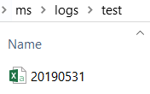

Figure : Input of T3LogsToSegmentApp

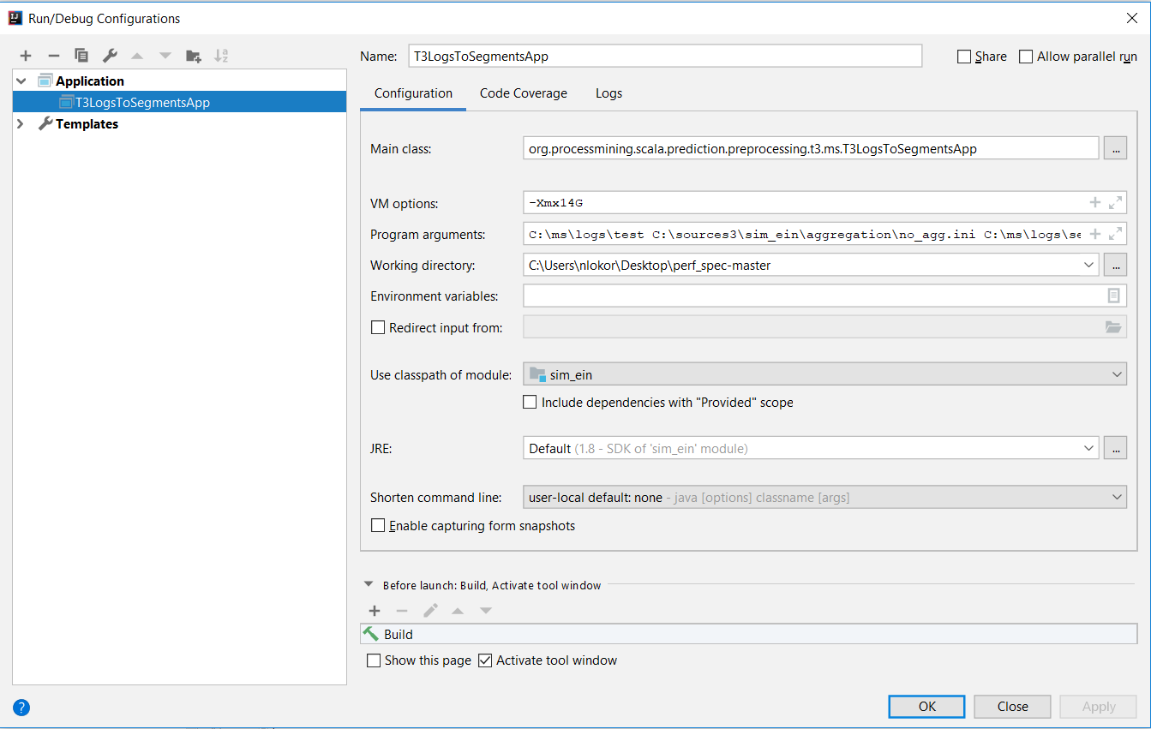

Figure : T3LogsToSegmentsApp configuration



1. Download the outlier detection project from <https://github.com/ozgekoroglu/Outlier_Detection_BHS> as a ZIP file.
2. Unzip the *Outlier_Detection_BHS-master* zip file.
3. Unzip the dist_clusters.rar file
4. (Optional) Execute the to obtain all the clusters that consists of similar days for each segment and weekday. These clusters are representative of the segment behavior. The result for each segment and weekday is stored in the folder called **dist_cluster.** We provide this folder with the results obtained for the period between 29.09.2017 and 30.03.2018 for Heathrow T3. Hence, execution of this step is not necessary unless someone wants to change the baseline for the analysis. If the baseline must be changed than the steps 1, 2, and 3 must be performed again. Execution is performed with following commands in the Anaconda prompt.

(outlier_detection) >cd location_of_clustering.py

(outlier_detection) >python clustering.py

1. Execute the Outlier_Detection_in_BHS.py with the argument that specifies the location of the segments we obtained in the step 2 with following commands in the Anaconda prompt. As a result of this step we obtain **test_day_weekday.csv** and **weekday.csv** in *analysis_psm_general* and *blockage_psm_general* folders.

(outlier_detection) >cd location_of_Outlier_Detection_in_BHS.py

(outlier_detection) >python Outlier_Detection_in_BHS.py location_of_segments

1. Open the folder ***psm_outlier***. Put the original event log that had been produced in the step 2 into this folder. Also put the *test_day_weekday.csv* file by changing its name to *outliers.txt.*

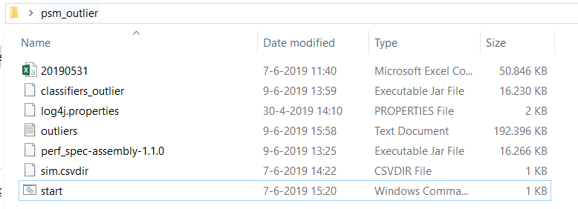

Figure : psm_outlier folder

1. To prepare CSV file(s) for import, put the file(s) into a directory and provide a description as a text ini file with extension .csvdir. This file must include the following fields:

|  |  |  |
| --- | --- | --- |
| **Field** | **Sample value** | **Comment** |
| dateFormat | dd-MM-yy HH:mm:ss.SSS | Datetime format in Java DateTimeFormatter format |
| zoneId | Europe/Amsterdam | Time zone ID in Java ZoneId format |
| startTime | 31-05-19 00:00:00.000 | Since then the performance spectrum should be computed, in the format described above |
| endTime | 01-06-19 00:00:00.000 | Until then the performance spectrum should be computed, in the format described above |
| caseIdColumn | id | Column name for case ID |
| activityColumn | activity | Column name for activity |
| timestampColumn | timestamp | Column name for timestamp |

Table : Content of .csvdir file

1. Execute ***start.cmd*** to open the Performance Spectrum Miner.
2. Import the .csvdir file via the *Open...* button.

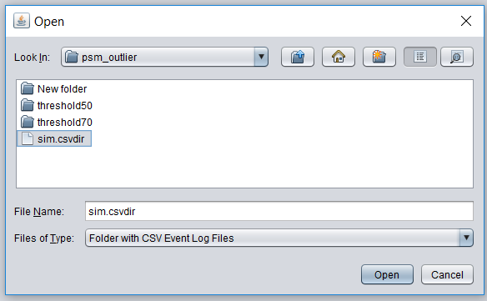

Figure : Importing .csvdir file into PSM

1. Choose parameters for generating the performance spectrum data.

* The transformed data will be stored on disk in the *Intermediate storage directory* together with a meta-data file (session.psm). You can load this transformed data also later via the *Open...* button.
* Type the following into the Custom Classifier Section. This classifier separates the outlier types in the performance spectrum miner.

**org.processmininginlogistics.classifiers.bp.example.SegmentClassifierExample**

* Choose *Process & open*
* The transformation may require some time and main memory depending on the *Bin size* chosen. Transformation for larger bin sizes are faster and require less memory.

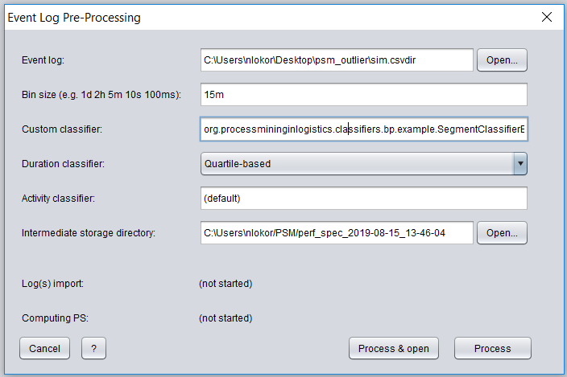

Figure : Event log pre-processing parameter selection

1. Click open in the *open pre-process dataset* window.

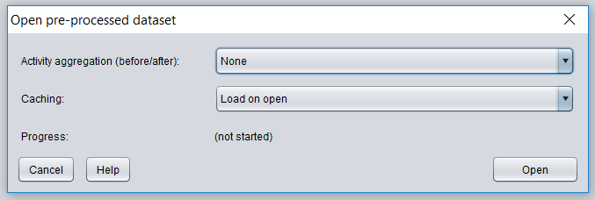

Figure : Opening pre-processed dataset

1. Close the PSM.
2. Open the *Intermediate storage directory*  for the performance spectrum that was obtained in the step 13. The **intermediate storage directory** is a path to an empty or non-existing folder where the performance spectrum data of the imported event data is stored. (Refer to [user manual](https://github.com/processmining-in-logistics/psm/blob/master/docs/user-manual.md) for the Performance Spectrum Miner for further information)
3. Add a config.ini file with the following content:

**[GENERAL]**

**paletteId = 4**

1. Copy the sorting_order.txt file from the repository and paste it in the *Intermediate storage directory*.

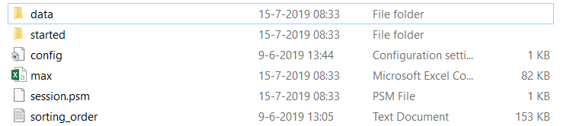

Figure : Intermediate storage directory

1. Go to the psm_outlier folder and execute start.cmd again. But, this time select the session.psm in the *Intermediate storage directory*.

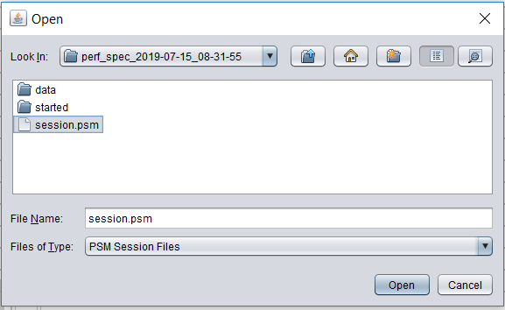

Figure : Opening session.psm

1. Explore the performance spectrum miner. For further information refer to the [user manual](https://github.com/processmining-in-logistics/psm/blob/master/docs/user-manual.md) for the PSM . Legend button shows the colors for different outlier types.
2. To see the problematic segments click on the *Legend* button and close it. A separate window is opened after closing the *Legend* window. To see the segments that behaved in their worst behavior select 1 for both comboboxes in the red rectangular and sort the values according to the importance variable.

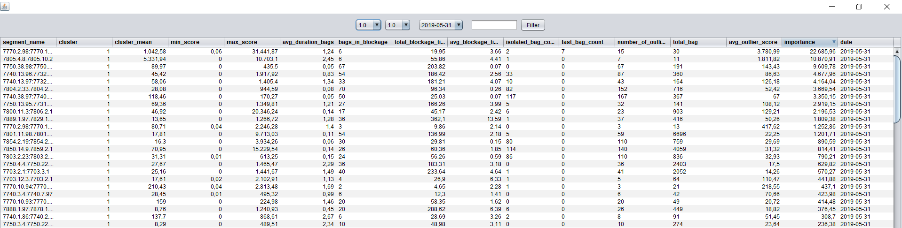

Figure : Visual Dashboard for Problematic Segments

1. By clicking on any line, one can see the blockages regarding the segment for the given day in the blockage window.

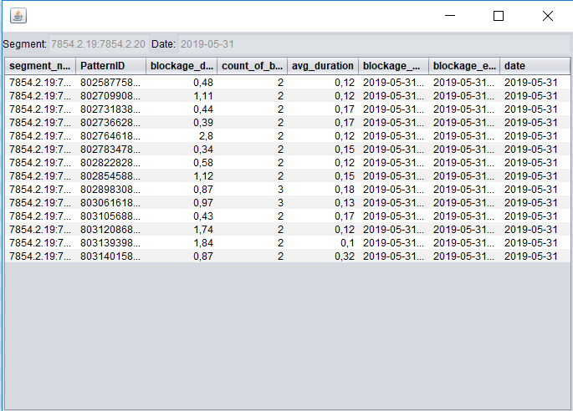

Figure : Blockage window

1. By clicking on any of the blockages, the user can see the selected blockage on the performance spectrum miner.

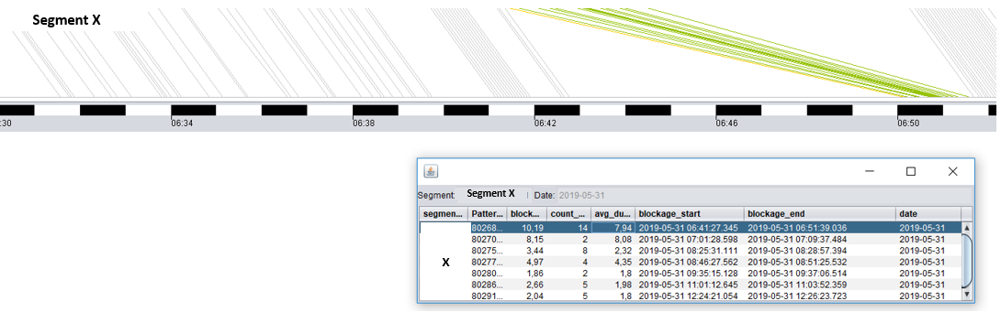

Figure : Blockage visualization on the PSM